**Topics: Descriptive Statistics and Probability**

1. Look at the data given below. Plot the data, find the outliers and find out $μ, σ, σ^{2}$

|  |  |
| --- | --- |
| **Name of company** | **Measure X** |
| Allied Signal | 24.23% |
| Bankers Trust | 25.53% |
| General Mills | 25.41% |
| ITT Industries | 24.14% |
| J.P.Morgan & Co. | 29.62% |
| Lehman Brothers | 28.25% |
| Marriott | 25.81% |
| MCI | 24.39% |
| Merrill Lynch | 40.26% |
| Microsoft | 32.95% |
| Morgan Stanley | 91.36% |
| Sun Microsystems | 25.99% |
| Travelers | 39.42% |
| US Airways | 26.71% |
| Warner-Lambert | 35.00% |

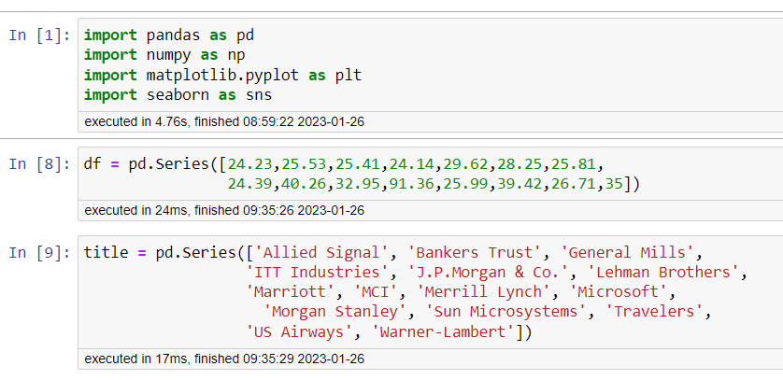

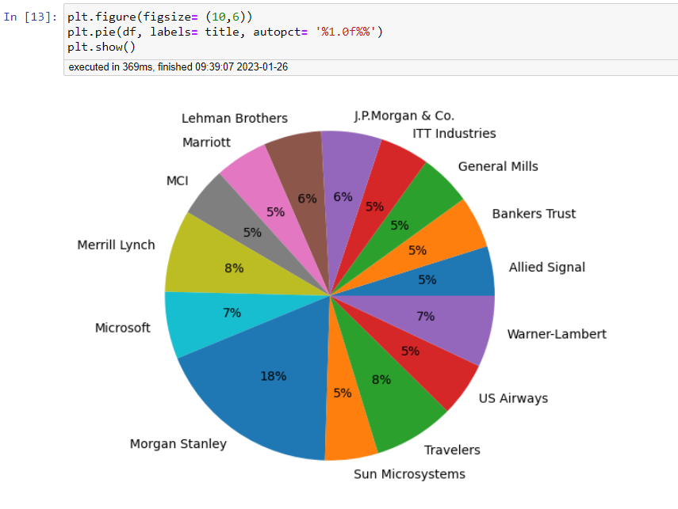

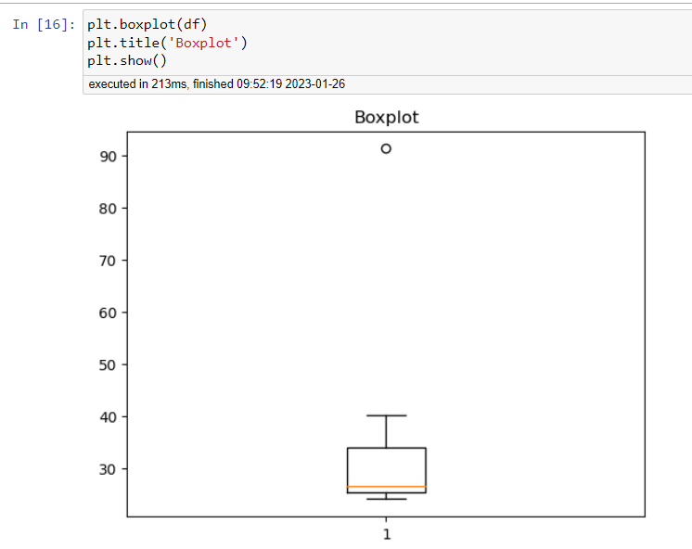

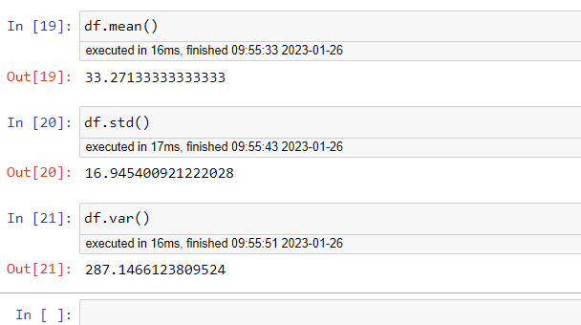



Answer the following three questions based on the box-plot above.

1. What is inter-quartile range of this dataset? (please approximate the numbers) In one line, explain what this value implies.
2. What can we say about the skewness of this dataset?
3. If it was found that the data point with the value 25 is actually 2.5, how would the new box-plot be affected?

Answer –

1. Q1 = 25th Percentile (Lower Quartile) = 5

Q3 = 75th Percentile (Upper Quartile) = 12

IQR = Q3 – Q1 = 12 – 5 = 7

IQR (Inter Quartile Range) indicates numbers of data points from dataset lies between 25th to 75th Percentile.

1. Right Skewed Dataset.
2. In that case there would be no Outliers on the given dataset because of the outlier the data had positive skewness it will reduce and the data will more normally distributed.



Answer the following three questions based on the histogram above.

1. Where would the mode of this dataset lie?

Answer – The mode of this dataset will lie between 4 to 8.

1. Comment on the skewness of the dataset.

Answer - Right Skewed as heavy mass of datapoints are shifted towards right.

1. Suppose that the above histogram and the box-plot in question 2 are plotted for the same dataset. Explain how these graphs complement each other in providing information about any dataset.

Answer - They both are right-skewed and both have outliers. The median of boxplot and mode in histogram is easily visible and seems to be in between 5 to 10.

1. AT&T was running commercials in 1990 aimed at luring back customers who had switched to one of the other long-distance phone service providers. One such commercial shows a businessman trying to reach Phoenix and mistakenly getting Fiji, where a half-naked native on a beach responds incomprehensibly in Polynesian. When asked about this advertisement, AT&T admitted that the portrayed incident did not actually take place but added that this was an enactment of something that “could happen.” Suppose that one in 200 long-distance telephone calls is misdirected. What is the probability that at least one in five attempted telephone calls reaches the wrong number? (Assume independence of attempts.)

Answer –

Let us define an event

E = The call is misdirected

then probability of the event E is = P(E) = 1 / 200

Therefore,

Probability that no attempted call reaches the wrong number = P(No) = 1 – P(E)

So, P(No) = 1 – (1/200) = 199/200

Probability that at least one in 5 attempted call reaches the wrong number = P(X)

P(X) = 1 - Probability that no attempted call reaches the wrong number

= 1 – (199/200 * 199/200 * 199/200 * 199/200 * 199/200)

= 1 – (199/200) ^5

P(X) = 0.025

1. Returns on a certain business venture, to the nearest $1,000, are known to follow the following probability distribution

|  |  |
| --- | --- |
| x | P(x) |
| -2,000 | 0.1 |
| -1,000 | 0.1 |
| 0 | 0.2 |
| 1000 | 0.2 |
| 2000 | 0.3 |
| 3000 | 0.1 |

1. What is the most likely monetary outcome of the business venture?
2. Is the venture likely to be successful? Explain
3. What is the long-term average earning of business ventures of this kind? Explain
4. What is the good measure of the risk involved in a venture of this kind? Compute this measure

1 Answer - 2000 $ is the most likely monetary outcome of the business venture as it has maximum probability P(x) = 0.3

2 Answer - The probability that the venture will make more than 0 or a profit

= 0.2+0.2+0.3+0.1 = 0.8

This states that there is good 80% chances for this venture to be making a profit.

3 Answer - The long-term average earning of business venture = ∑ X * P(x) = 800 $ which means on an average the returns will be + 800$.

4 Answer - The good measure of the risk involved in a venture of this kind depends on the Variability in the distribution. Higher Variance means more chances of risk:

Var (X) = E(X^2) - (E(X))^2 = 2800000 - 800^2 = 2160000